**Assignment - Unix Commands**

**NAME:** Deepesh Patil

**MIS:** 112215055

**GROUP:** 2

1. **who**

Displays currently logged in users



1. **pwd**

Displays the **P**resent **W**orking **D**irectory(pwd)



1. **mkdir <DirectoryName>**

Command to create an empty folder in the present directory



1. **rmdir <DirectoryName>**

Command to remove a folder from the current directory



1. **ls**

Lists all the files and directories and also highlights the folders.



1. **touch <FileName>**

Creates an empty text file

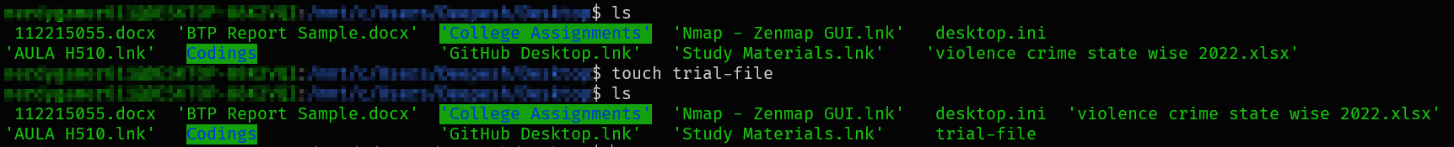

1. **cp <FilePath1> <FilePath2>**

Makes a copy of a file present in FilePath1 to a file at Filepath2.



1. **mv <src> <dest>**

Moves a file for source location to destination location.

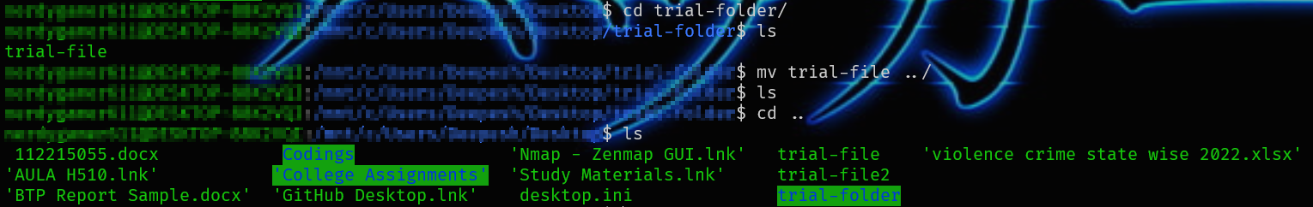

1. **rm <FileName>**

Removes a file



1. **chmod <OPTION> <FileName>**

Lets you change the read, write, and execute permissions on your files.

**OPTIONS:**

Change the mode of each FILE to MODE. With --reference, change the mode of each FILE to that of RFILE.

-c, --changes

like verbose but report only when a change is made

-f, --silent, --quiet

suppress most error messages

-v, --verbose

output a diagnostic for every file processed

--no-preserve-root

do not treat '/' specially (the default)

--preserve-root

fail to operate recursively on '/'

--reference=RFILE

use RFILE's mode instead of MODE values

-R, --recursive

change files and directories recursively

--help

display this help and exit

--version

output version information and exit

1. **cal**

Shows calender of the ongoing month

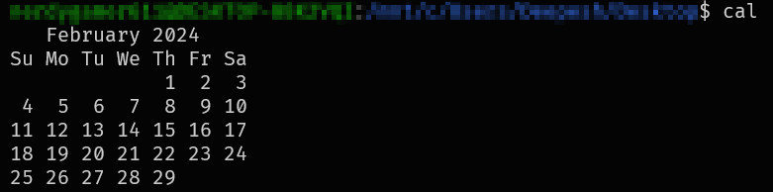

1. **file <FileName>**

Determines the type/format of the file

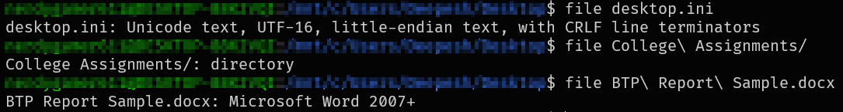

1. **sort**

Used to sort the records or a file in a particular order.

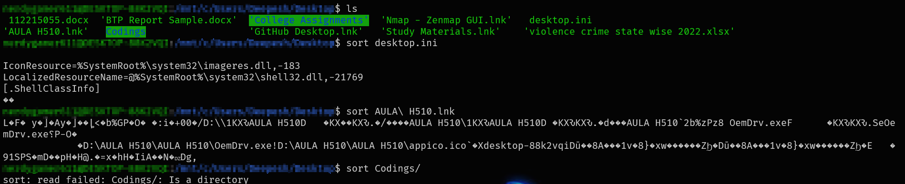

1. **grep**

**G**lobal search for **R**egular **E**xpressions and **P**rint(grep) is a command to find words or phrases from a list and print the matching lines.



1. **passwd**

This command allows us to change the password of the current user.

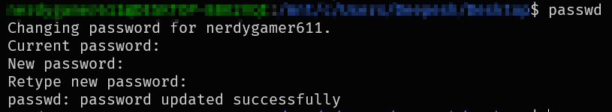

1. **clear**

In the terminal, this command is used to clear all the previous outputs.

Before Clear:

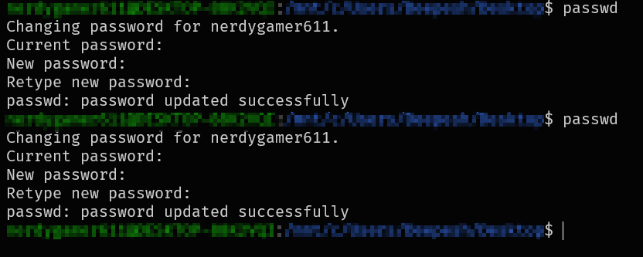

After clear:



1. **cat**

This command concatinates files and prints the standard outputs

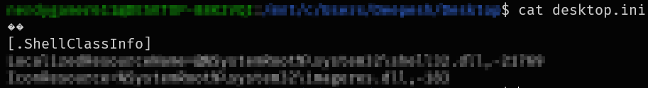

1. **cd <Path>**

**C**hange **D**irectory (cd) command allows us to change the working directory.

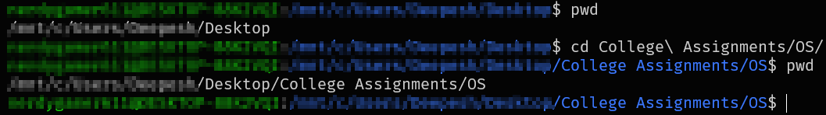

1. **cmp**

This command compares 2 files byte by byte and helps to find out if they are identical or not.

